To avoid cross contamination, store food in a refrigerator based upon the minimum required internal cooking temperature of the product.

 | 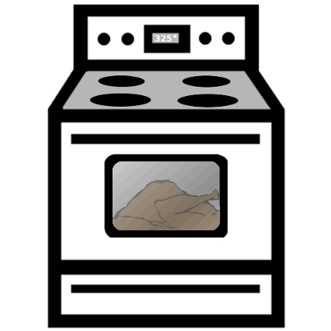
Top Shelf: Ready-to-Eat Foods  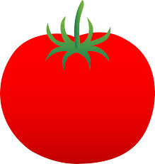  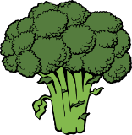 | N/A
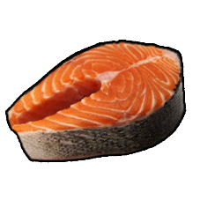  Whole Raw Beef, Pork, Fish, Eggs  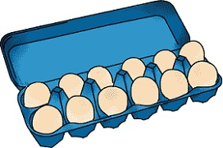 | 145°F
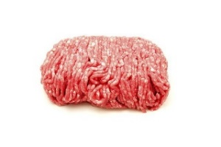  Raw Ground Meat | 155°F
Bottom Shelf: Raw Poultry  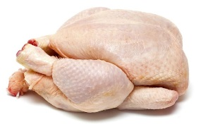 | 165°F

